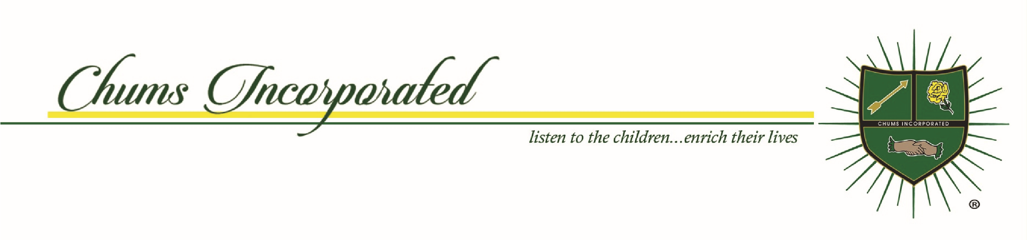
National Officers
THE CHUMS, INCORPRATED
RELEASE AND HOLD HARMLESS AGREEMENT
I, _____________________________________________, the parent and/or guardian of minor/or myself________________________, participating in___________________, The Chums, Incorporated activity beginning on ___________________________ 20---.
I understand and believe that necessary supervision and precautions will be taken to ensure safety of me and/or child/children during the activity, including COVID-19 precaution protocols. I consent to me and/or child/children’s participating in the activity and acknowledge that I fully understand my participation may involve risk of serious injury or death, including losses which may result not only from my own actions or the child’s own actions, inactions, or negligence, but also from the actions, inactions or negligence of others, the condition of the facilities, equipment, or areas where the activity is being conducted.
I agree to use my personal medical insurance as a primary medical coverage payment if accident or injury occurs. I consent to emergency medical treatment in the event such care is required.
I further agree that photographs, pictures, slides, movies, video, or other media coverage of me and/or my child may be taken in connection with my participation in the Activity and used for any legal purpose, without compensation from Chums Incorporated, its officers, directors, employees, members, and agents of each of them.
I understand the risks involved with participation in the activity; I hereby voluntarily and willingly assume responsibility for all risks and dangers associated with me and/or my child/children’s participation in the Activity.
In consideration of my child/children’s or my participation in the Activity, I hereby waive all claims or causes of action against The Chums, Incorporated, its officers, directors, employees, members, and agents of each of them, arising out of my child/children’s participation in the activity and hereby release, hold harmless, and discharge its officers, directors, employees, members and agents of each of them from all liability in connection therewith except such loss or damage which was caused by the gross negligence or willful misconduct of Chums, Incorporated, its officers, directors, employees, members and agents of each of them.
I have read this release and hold harmless agreement and understand the terms used in it and their legal significance. This waiver and release is freely and voluntarily given with the understanding that right to legal recourse against The Chums, Incorporated, its officers, directors, employees, members and agents of each of them is knowingly given up in return for allowing myself and/or child/children’s participation in the activity. My signature on this document is intended to bind not only myself but also my successors, heirs, representatives, administrators, and assigns.
_______________________________________________________
Participant’s Name and Signature
________________________________________________________
Parent Name and Signature if Participant is under 18 Years old.

Barbara J. Neville
President
Marsha Ingersoll Vice President
Joyce Freeman-Baker
Recording Secretary
Sharletta McKinney
Corresponding Secretary
Irene Crowell
Financial Secretary
Charades Estes Treasurer
Susan Odom Houze Parliamentarian
Lynn Rosario
Member-at-Large
Viola Burton Mitchell Public Relations Officer
Edna Edwards Williams
Historian/Journalist
Ruth Carter
Sergeant-at-Arms
DeLynda Wilson
Registered Agent
Betty Walker, Esq. General Counsel
Elizabeth Saunders Immediate Past National President
Our Founders
Mary Ward Barnes
Joyce Tate Brown
Theodore Jackson Cora
A Non-Profit
501c3 Organization www.chums-inc.org

